## CA-3 Report

### 

**TITLE:** RESTAURANT RESERVATION AND TABLE MANAGEMENT SYSTEM WEBSITE

**INTERNET PROGRAMMING LABORATORY-CSE326**

PROJECT REPORT

***by***

|  |  |  |  |  |
| --- | --- | --- | --- | --- |
| Sr. No. | Registration No | Name of Students | Roll No. | Section |
| 1 | 12313835 | Mitesh Ravindra Kothe | 20 | K23KP |
| 2 | 12313906 | Kumari Kriti Singh | 21 | K23KP |
| 3 | 12314448 | Vaibhav Kulshrestha | 31 | K23KP |



**School of Computer Science Engineering**

**Lovely Professional University**

**Jalandhar, Punjab**

**TABLE OF CONTENTS**

|  |  |  |
| --- | --- | --- |
| **SNO** | **TITLE** | **PAGE NO.** |
|  | Introduction……………………………………. | 1-2 |
|  | Technologies Used…………………………… | 2-4 |
|  | Modules………………………………... | 4-8 |
|  | Website Snapshots…………………………… | 8-11 |
|  | References………………………………. | 12 |

#### **INTRODUCTON**

**In the ever-evolving landscape of the hospitality industry, the importance of efficient restaurant management cannot be overstated. A pivotal aspect of this management is the seamless orchestration of reservations and the optimal allocation of tables. Aiming to address this need, we present a conceptual front-end implementation of a Restaurant Reservation and Table Management System using HTML, CSS, and JavaScript.**

**At the forefront of our design philosophy is a commitment to user-centricity. The landing page serves as the initial point of interaction, providing a welcoming atmosphere through a clean layout and visually appealing elements. The page boasts a prominently placed header, succinctly declaring the purpose of the system - "Restaurant Reservation System." This immediate communication sets the user's expectations and establishes a clear narrative.**

**A fundamental feature of our system is the ability for users to seamlessly make reservations. The "Make Reservation" section introduces a carefully crafted form, designed to gather essential information while maintaining user friendliness. The form comprises fields such as Name, Email, Date, Time, and Party Size, strategically arranged in a visually pleasing grid layout for a successful reservation.**

**Recognizing the diverse ways in which users access online platforms, our front-end implementation prioritizes responsive design. CSS media queries are employed to ensure that the system adapts seamlessly to various screen sizes, from desktop monitors to tablets and smartphones. This responsiveness is not only a nod to current user behaviors but also anticipates the increasing prevalence of mobile-centric interactions in the digital landscape.**

**The responsive design principles are embedded in the code, allowing the content to fluidly adjust its layout and styling based on the device's screen dimensions. This adaptability is a fundamental aspect of creating an inclusive user experience that caters to the preferences and habits of a broad audience.**

**Aesthetic appeal is integral to user engagement. The choice of colors, typography, and overall styling elements is purposeful, aiming to create a visually cohesive and memorable experience. The color scheme harmonizes with the restaurant's branding, promoting a sense of familiarity and unity.**

1

**Buttons and interactive elements are designed with both form and function in mind. The visual hierarchy guides users through the interface, ensuring that important actions, such as submitting a reservation, are easily discernible. Consistency in design elements contributes to a polished and professional appearance, aligning with the expectations of modern web users.**

**Our front-end implementation of a Restaurant Reservation and Table Management System encapsulates a harmonious blend of functionality and aesthetics. It strives to transcend the conventional boundaries of online restaurant services by providing a platform that is not only efficient but also visually inviting. The carefully chosen design elements, from the landing page to the reservation form and table management section, aim to create an immersive and user-friendly experience.**

**TECHNOLOGIES**

In the ever-evolving world of web development, creating a robust and user-friendly front-end for a Restaurant Reservation and Table Management System demands a strategic selection of technologies. HTML, CSS, and JavaScript form the bedrock of this implementation, seamlessly blending functionality and aesthetics to provide a comprehensive user experience.**HTML: The Structural Foundation**HTML (Hyper Text Markup Language) serves as the structural foundation of our front-end implementation. It defines the logical structure of the web page, allowing us to organize content hierarchically. Elements such as headings, paragraphs, forms, and lists are strategically employed to create a semantically meaningful document.The landing page structure begins with a standard HTML5 document declaration, specifying the document type and character set. The <head> section contains metadata, including the title of the page and links to external stylesheets and scripts. The <body> section encapsulates the visible content, from headers and sections to forms and footers.The application of semantic tags such as “<article>”, “<section>”, and “<nav>” ensures a well-organized and easily navigable structure.For instance, the reservation form is constructed using HTML form elements. “<label>” tags provide a descriptive label for each input field, enhancing accessibility and user understanding. The use of the “required” attribute ensures that essential information is provided, promoting data integrity in the reservation process.

2

**CSS: Aesthetic Alchemy and Responsive Design Mastery**Cascading Style Sheets (CSS) serves as the artistic maestro of our front-end symphony, dictating the visual appearance and layout of the web page. This technology transcends mere stylization; it is the brushstroke that paints the canvas of our interface, ensuring a visually appealing and harmonious design.At the heart of our design philosophy is responsive design, a principle facilitated by CSS media queries. These queries empower the website to adapt its layout and styling dynamically based on the dimensions of the user's device, be it a sprawling desktop monitor or a compact smartphone screen. The responsive design is not merely a feature; it's a commitment to providing a consistent and delightful experience across diverse platforms.Selectors and rules within the CSS stylesheet are meticulously crafted to maintain a coherent visual identity. From the color palette to typography choices, each element is a deliberate choice aimed at creating a user interface that is not just functional but also aesthetically pleasing. The use of flexbox and grid layout enhances the organization of elements, contributing to a responsive and fluid design that seamlessly accommodates varying screen sizes.Transitions and hover effects, employed judiciously on interactive elements like buttons, add a layer of sophistication to the user experience. For instance, the "Submit Reservation" button undergoes a color transformation on hover, signaling interactivity and inviting user engagement.

**JavaScript: Breathing Life into Interactivity and Form Validation**JavaScript, the dynamic scripting language, injects life into our front-end by introducing interactivity and responsiveness. At the core of its functionality is the ability to respond to user actions, validate form inputs, and enhance the overall user experience.In our system, JavaScript is instrumental in handling form submissions. An event listener is employed to capture the form submission event, and upon submission, a corresponding JavaScript function is invoked. This function, while serving as a placeholder in our front-end representation, lays the groundwork for future integration with back-end functionalities. In a fully realized system, this is where communication with a server would take place, facilitating the storage and processing of reservation data.Beyond form submission, JavaScript takes center stage in form validation. The script ensures that users provide valid and complete information before submitting the reservation form. Real-time feedback and error messages contribute not only to data integrity but also to a smoother user experience by preventing common input errors.

3

The "Reserve Table" section, though conceptual in the front-end, serves as a beacon of anticipation for future integration with back-end dynamism. HTML structures and potential CSS styling lay the groundwork for a dynamic interface that could dynamically fetch and display real-time information about restaurant tables. This forward-thinking approach ensures scalability and adaptability as the system evolves.

In a nutshell, the integration of HTML, CSS, and JavaScript in our front-end implementation for a Restaurant Reservation and Table Management System is a testament to the synergies of technology. HTML constructs the logical foundation, CSS paints the visual canvas, and JavaScript adds the dynamic brushstrokes. The result is a front-end experience that transcends the ordinary, providing users with a seamless and visually inviting journey through the realm of restaurant reservations and table management.

**MODULE**

In the dynamic landscape of web development, creating a Restaurant Reservation and Table Management System demands not just functionality but also a sophisticated and maintainable front-end architecture. This exploration delves into the concept of modules within the context of HTML, CSS, and JavaScript, unraveling the strategic deployment of this modular approach to elevate the user experience, streamline development, and ensure future scalability**.**

4

1. **Foundations of Modularity in HTML:**At the core of our front-end architecture is HTML, the language that provides structure and semantics to our content. The modular approach begins with breaking down the user interface into distinct, self-contained modules. Each module is designed to encapsulate a specific aspect of the system, fostering clarity and reusability.For instance, the reservation form, table management section, and footer are identified as separate modules. These are then encapsulated within distinct HTML files, allowing for a clear separation of concerns and facilitating ease of maintenance and updates.

This modular HTML structure not only enhances maintainability but also sets the stage for reusability, as individual modules can be utilized across various sections of the application.

1. **Styling Harmony with CSS Modules:**CSS steps in as the stylistic maestro, and a modular approach here involves encapsulating styles within specific modules. Adopting clear naming conventions ensures that styles are applied selectively to the targeted HTML components, enhancing maintainability and organization.

CSS modules not only facilitate the fine-tuning of the visual aesthetics but also contribute to the overarching goal of a modular architecture, ensuring that styles are applied contextually to each module.

1. **Dynamic Interactivity with JavaScript Modules:**JavaScript injects dynamism and interactivity into our front-end, and the modular approach extends to the encapsulation of related functionality within distinct JavaScript modules. These modules, each responsible for specific behaviors, contribute to a well-organized and maintainable codebase.

5

By encapsulating functionalities within modules, JavaScript promotes a clear separation of concerns, making it easier to understand, test, and modify individual components. This modular structure also aligns with the principles of maintainability and code readability.

1. **Responsive Design through Modular Interaction:**The modular structure extends beyond isolated HTML, CSS, and JavaScript components. It encompasses the interaction and responsiveness of these components to various screen sizes, ensuring a seamless and adaptive design.Media queries within CSS modules allow for the definition of styles tailored to different screen dimensions. This responsive design strategy ensures that modular components adapt gracefully to the diverse landscape of devices This approach not only contributes to a seamless user experience but also aligns with the overarching modular theme, where each component autonomously responds to the constraints of different devices.
2. **External Libraries as Modular Components:**In addition to creating custom modules, the front-end can benefit from the integration of external libraries and frameworks as modular components. Libraries like Bootstrap for styling or frameworks like Vue.js for dynamic behavior provide pre-built, modular elements that enhance the efficiency of development.For instance, using Bootstrap for styling certain components or integrating Vue.js for dynamic and reactive behavior can significantly expedite the front-end development process. These external components seamlessly fit into the modular structure, augmenting the overall functionality and visual appeal of the system.
3. **Accessibility and User-Centric Modules:**Modularity isn't just about code organization; it extends to ensuring accessibility and a positive user experience. Each module should be designed with accessibility principles in mind, making the application usable for individuals with diverse needs.For example, form elements within the reservation module should include appropriate labels for screen readers, and interactive components should have keyboard navigation considerations. This commitment to accessibility aligns with the modular philosophy by addressing not just code structure but the inclusivity and usability of the entire system.

6

1. **Ensuring Adaptability for Future Scalability:**The modular front-end isn't a static entity; it's designed to evolve with the growth of the application. As new features or sections are introduced, they can seamlessly integrate into the existing modular structure, fostering scalability.When expanding the system, the modular approach facilitates the addition of new modules or the modification of existing ones without compromising the integrity of the entire application. This scalability is essential in the ever-evolving landscape of restaurant management systems, allowing for the seamless integration of future functionalities.
2. **Conclusion: Orchestrating Modular Brilliance in Front-End Development**In conclusion, the adoption of a modular approach in the front-end development of a Restaurant Reservation and Table Management System is a strategic decision that yields a plethora of benefits. HTML, CSS, and JavaScript modules collaborate seamlessly to enhance maintainability, reusability, and responsiveness.The modular structure adheres to the principles of clean code architecture, making the system more understandable and extensible. It promotes a separation of concerns, allowing developers to focus on individual components without being overwhelmed by the complexity of the entire system.As we navigate the intricacies of restaurant reservation and table management, the modular front-end stands as a testament to the elegance and efficiency achievable through thoughtful technological choices. It's not just a development strategy; it's a philosophy that propels the system toward adaptability, scalability, and an enriched user experience. In embracing the modular brilliance, the front-end becomes more than code; it becomes a symphony of meticulously crafted components, orchestrated to deliver a seamless and delightful digital dining experience.

7

**WEBSITE SNAPSHOTS**:

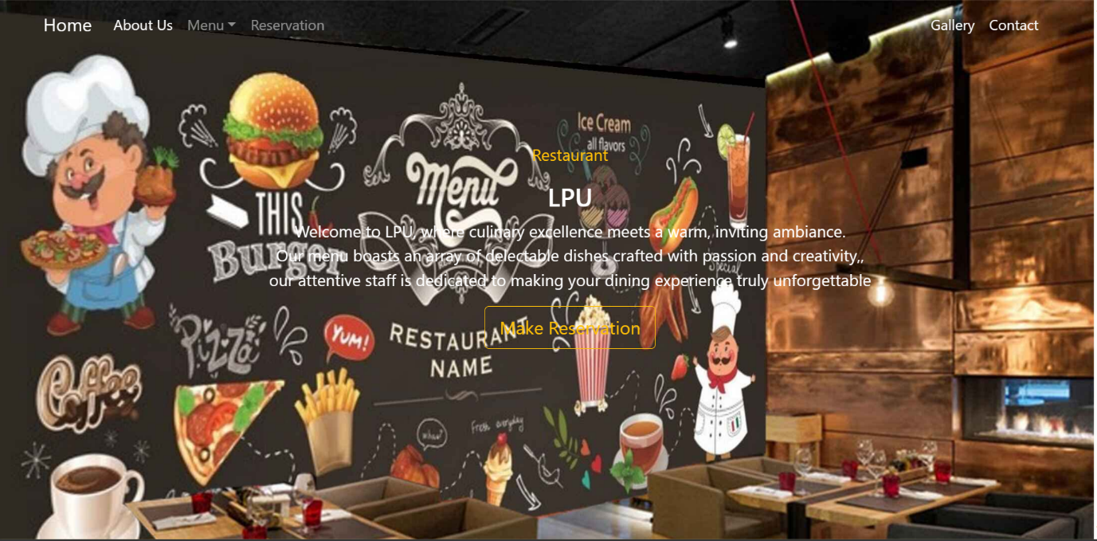

**Figure 1. Shows top view of home page**

8

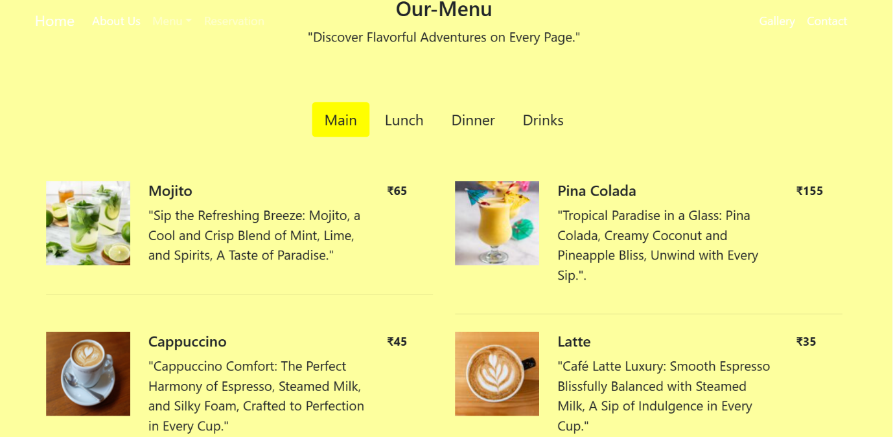

**Figure 2. Describes view of the content**

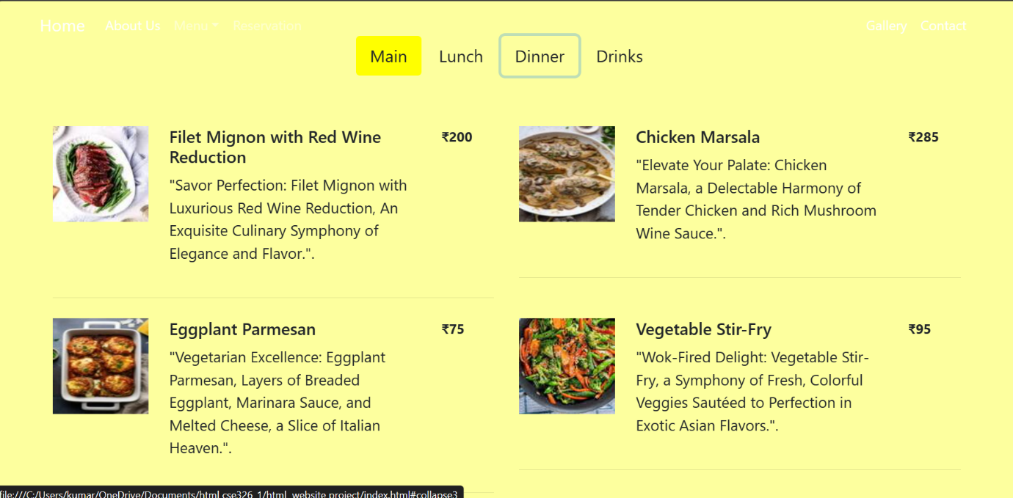

**Figure 3. Describes view of the content**

9

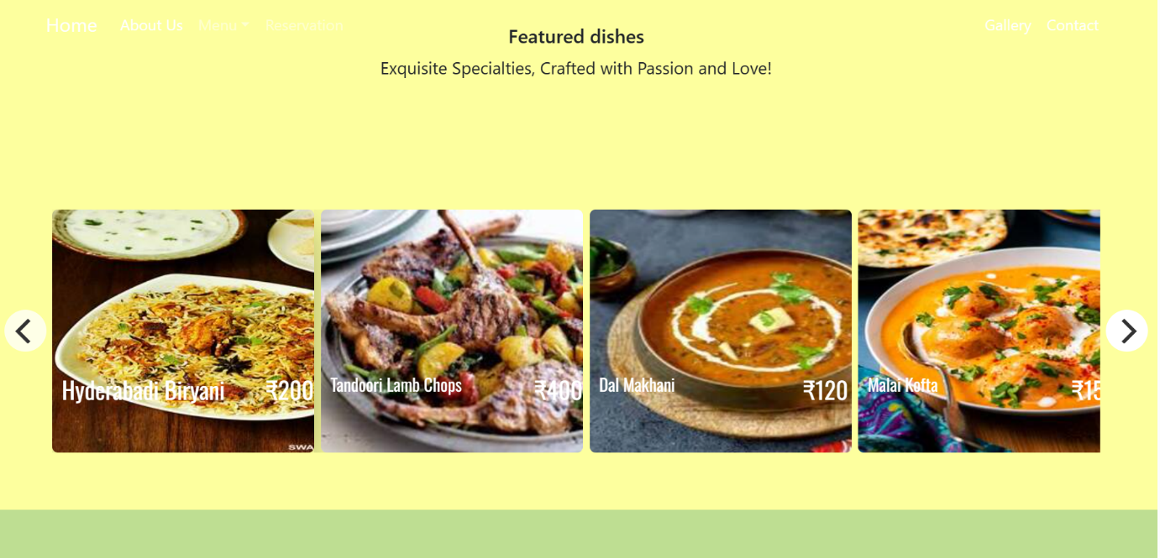

**Figure 4. Describes view of the content**

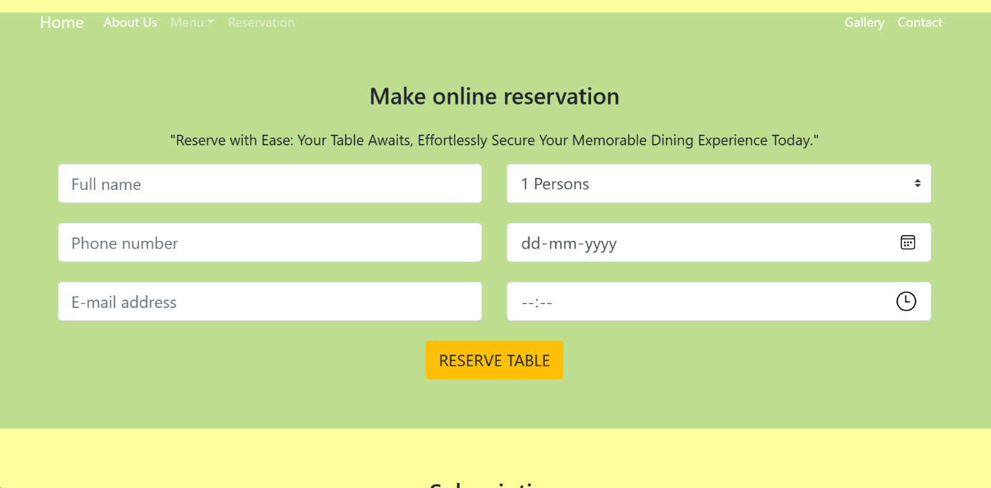

**Figure 5. Reserve table**

10

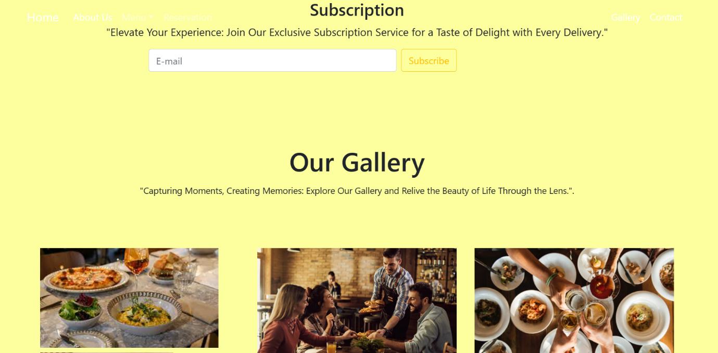

**Figure 6. Describe view of the content**

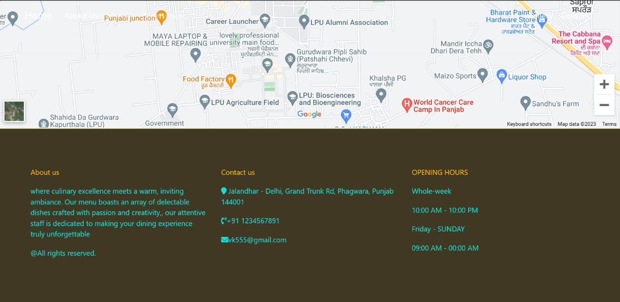

**Figure 7. Shows bottom view of the pages**

11

**REFERENCES**

12

1. <https://www.w3schools.com/>
2. <https://resos.com/feature/restaurant-system-for-table-management>
3. <https://squareup.com/gb/en/point-of-sale/restaurants/features/table-management-system>
4. <https://www.ibnbattutamall.com/en/blog/types-of-cuisine-and-their-famous-dishes>